|  |  |  |
| --- | --- | --- |
|  | **Macksville High School**  **Email:** [**Macksville-h.school@det.nsw.edu.au**](mailto:Macksville-h.school@det.nsw.edu.au)  **Website: www.macksville-h.schools.nsw.edu.au**  **NEWSLETTER**  **TERM 1 ISSUE 1 FEBRUARY 2014** |  |
| PO Box 611  40 Boundary Street  MACKSVILLE NSW 2447 Phone: 02 6586 1066  Fax: 02 6568 2802 |

**School Captains & Vice Captains**

|  |  |
| --- | --- |
| Calendar Dates | |
| FEBRUARY | |
| 20 &21 | Yr7 Excursion to Valla Beach Resort |
| 20 | Zone Swimming Carnival-Kempsey |
| 20 | Yr11 Sport Coaching – Pool |
| 25 | **P&C Meeting - 6.30pm** |
| 27 | School Photos |
| 28 | Photo –catch-up |
| 28 Feb. -Mar. 5 | Yr11 Dive |
| MARCH | |
| 3 | **Parent/Teacher night for**  **Yrs 7, 9 & 12** |
| 10 | **Yr7 male & female & Yr 9 boys immunisations** |
| 17 | **Parent/Teacher night for**  **Yrs 8, 10 & 11** |

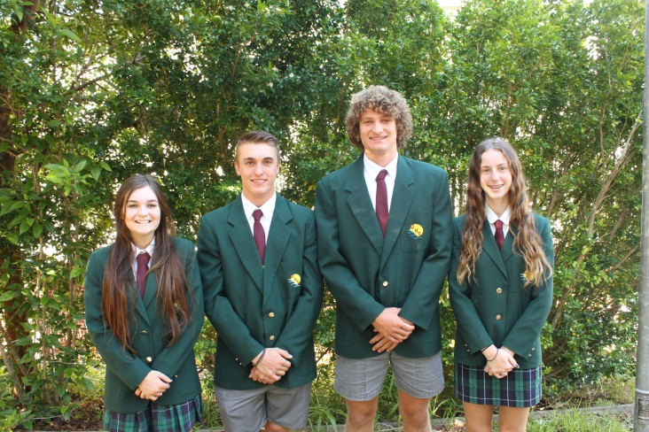

Our 2014 student leaders …..From left to right:

Captains Tess Lewis and Max Vernon and Vice Captains Stuart Mason, Raina Schmidt

|  |  |
| --- | --- |
| Calendar Dates | |
| 20 | Yr7 Excursion to Valla Beach Resort |
| 20 | Zone Swimming Carnival-Kempsey |
| 20 | Yr11 Sport Coaching – Pool |
| 25 | **P&C Meeting - 6.30pm in TAS kitchen?? - Tuesday** |
| 27 | School Photos |
| 28 | Photo –catch-up |
| 28 Feb. -Mar. 5 | Yr11 Dive |
| 3 | **Parent/Teacher night for**  **Yrs 7, 9 & 12** |
| 20 | Yr7 Excursion to Valla Beach Resort - |
| 20 | Zone Swimming Carnival-Kempsey - |
| 20 | Yr11 Sport Coaching – Pool - |
| 25 | **P&C Meeting - 6.30pm in TAS kitchen??** |
| 27 | School Photos |
| 28 | Photo –catch-up |
| 28 Feb. -Mar. 5 | Yr11 Dive |
| 3 | **Parent/Teacher night for**  **Yrs 7, 9 & 12** |

**Canteen Roster**

**February 2014**

Monday 17 S Compton, R Smith

Tuesday 18 Helpers Needed

Wednesday 19 Helpers Needed

Thursday 20 D Jackson

Friday 21 Helpers Needed

Monday 24 S Compton

Tuesday 25 San Drine

Wednesday 26 Helpers Needed

Thursday 27 J Beggs

Friday 28 G Welsh

Mon. March 3 S Compton, R Smith

The School Canteen is in desperate need of helpers! Can you spare a few hours between 9am – 2pm once a fortnight, monthly or even occasionally when needed (lunch will be provided). If you can help – please phone Ros at the Canteen on 65681453 or at the school on 6568 1066.

**Swimming Carnival**

**at Macksville Pool**

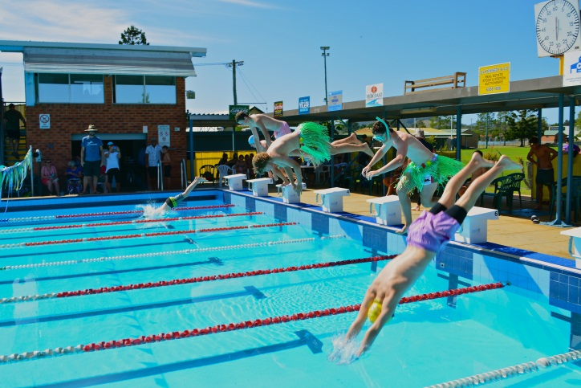

See more photos of the *Swimming Carnival*

on the School’s website…. [**www.macksville-h.schools.nsw.edu.au**](http://www.macksvilleh.schools.nsw.edu.au)

Swimming report and House Captains next Newsletter.

**From our Principal**

Dear Parents,

I would like to welcome back all of our students to the 2014 school year and would particularly like to extend a warm welcome to our Year 7 students. Macksville High School will continue in 2014 to provide a learning environment that is safe, positive and an encouraging experience for all.

My name is Erica Lyne and I am the newly appointed Principal of this great school. I am extremely proud and honoured to have been selected to serve this learning community. Macksville High School is an outstanding comprehensive high school with enormous potential for future growth. We have wonderful opportunities for our students to involve themselves in academic, cultural, leadership and sporting pursuits within excellent learning facilities.

My vision for Macksville High is to continue to build the school’s capacity so that every student achieves what they are personally capable of. This will mean a focus on teaching and learning as well as having high expectations of respectful and responsible behaviour.

I would also like to welcome Mr Tim Lukins to our school as our Careers Advisor, and Ms Susan Elgar as our Tutorial Centre teacher.

It was a pleasure to see so many of our students participating in events as well as our talented swimmers breaking records. I would like to thank all those who participated and made our swimming carnival a successful day, in particular to Mr Gough for his efforts in organising the day.

Congratulations to the SRC and Mrs Larissa Atkins for the Valentine’s Day fundraising effort. The school was a sea of roses and balloons, with proceeds going to Red Cross and the Heart Foundation.

I look forward to working together with our school and community partners towards best outcomes for our students.

Kind Regards

Erica Lyne

**Mathematics News**

**Calculators**

The use of calculators is compulsory in NSW for Australia wide Maths exams. To support students in this regard, Macksville High School students are required to bring a suitable scientific calculator to each Maths lesson. Failure to do so can affect students’ learning as staff members are unable to instruct students in the correct use of the calculator and this can then have an impact on their grades.

A Calculator (model Sharp EL – 531 XB) can be purchased from the front office at a cost of $20. It is preferred that all students use the same calculator to enable efficient instruction to be given. Student Assistance is available for parents who may possibly need help to finance this purchase. ***Please can you ensure your child brings his/her calculator to school each day so staff can assist your child to achieve their potential?***  
  
**Homework Centre**

The Mathematics department will supervise a homework centre in room C1 from 3.20 to 5.00pm on Thursday afternoons. Tutoring is given in learning maths concepts and assistance in completing homework from other subjects may also be obtained. If you are interested in your child attending please ask him/ her to collect a note from the Maths staff room.

Please contact me at the school if you have any queries in this matter.

**Moyra Mendham  
*Head Teacher Mathematics***

**Tim Hopper**

Former student from Macksville High School has just graduated from Newcastle University with Class 1 Honours in Chemical Engineering – advised by Debbie Hopper (mother)

**Helping Learner Drivers Become Safer Drivers**

A free 2 hour workshop provided by NSW Roads and Maritime Services.

The workshops provide practical advice about:

* The new changes to the Learner Driver Permit,
* The new Safer Drivers Course,
* How to use the Learner Driver Log Book,
* How to plan driving sessions,
* How to deal with difficulties that may arise during driving practice,
* The importance of giving the learner constructive feedback.

The workshops are designed to help learner driver supervisors plan the best on-road experience for learner drivers and include information about the current licence conditions for learner and provisional drivers, young driver safety issues and low risk driving.

Who should attend:

* Parents, friends or relatives who are/will be supervising drivers
* Learner drivers are welcome to attend if accompanied by their supervisor

The workshop will be presented by the Enterprise and Training Company (ETC) in partnership with Roads and Maritime Services (RMS).

**Careers News**

1. *Year 10 Work Experience*: coming up on the week of April 7-11 (last week of term 1) and requiring your child to BE ORGANISED! All being well, their ‘Work Experience Kits’ should be published ready for students next week- and I will go through them with each group when they are; completed signed paperwork would need to be returned to me AT LEAST 2 weeks prior to the work experience! ie. by 24.03.14! work experience is an **amazing opportunity** for our students- to experience working in a business that they are interested in, a bit like ‘try-before-you-buy’! Currently this week is the only planned opportunity for students to experience industry.

2. *Tax File Numbers*: part of ones 'working life' involves...dealing with the tax system!! A Tax File Number is a number unique to a tax payer so that the ATO can manage taxation; while they are NOT compulsory, if a student doesn't get a tax file number they will have to pay the highest rate of tax any time they have paid employment!! ie. taxman gets nearly 50c for every dollar earned!! Please come and see me to get the school student application form in the Careers Office.

3. *UMAT and Medicine*: The Under Graduate Medical Admissions Test is one of the 3 bars that any student wanting to complete study in medicine (and most dentistry) courses will need to jump over!! [the other 2 are an ATAR rank to meet and a personal suitability interview- and all of equal importance]. It is a multiple choice test aiming to assess an applicant’s suitability for studying medicine. All year 12 students have been sent an email giving the dates (cutoff for application and test date) and should be encouraged to go and check their DEC emails...sooner than later!

4. *Year 11 Subject Changes*: Last Friday (14.02.14) was the last day for Year 11 students interested in swapping some of their chosen subjects to complete the required school paperwork! If you (parents/carers) have any concerns in relation to this, please come and talk to the school about it. Now it's time for all students to start 'rowing hard' in achieving outcomes and assessment for their chosen subjects...





Dear Parents

Parent/Teacher/Student interviews for **YEARS 7, 9 & 12** will be held at 4**.00pm – 6.00pm** on Monday 3 March 2014.

You can now book interviews at times that suit ***YOUR FAMILY BEST***.

Go to [www.schoolinterviews.com.au](http://www.schoolinterviews.com.au) and follow these simple instructions.

**BOOKINGS CLOSE FRIDAY 28 FEBRUARY 2014**



Go to [www.schoolinterviews.com.au](http://www.schoolinterviews.com.au)

Enter THIS school event code: (68ZQ9) then follow the 3 simple steps below.

**68ZQ9**





When you click ***finish***, your interview timetable will be emailed to you automatically - **check your junk mail folder** if you do not receive your email immediately.

You can return to [www.schoolinterviews.com.au](http://www.schoolinterviews.com.au) at any time, and change your interviews - until bookings close.

For parents that don’t have access to the internet at home, at work, at a friend’s house or on their phones, please phone the school on 6568 1066 where our administrative staff will assist you. Interviews are strictly 5mins and spaces are limited. If you require more time, please contact your teacher directly to make alternative arrangements.

Parents can change their interview bookings, any time prior to the closing date, by re-visiting the [www.schoolinterviews.com.au](http://www.schoolinterviews.com.au) website, and using the event code. Remember to use the same name and email address, you used when you made your original booking. Parents wishing to change their interview times after the closing date, should contact the school directly on: 6568 1066.

We would love to hear what you think about online booking. If you get time, click on the “contact us” button on the [www.schoolinterviews.com.au](http://www.schoolinterviews.com.au) website, and leave some feedback - anonymously if you wish, but please include the school’s name and suburb.

**Macksville High School —**

**2014 Contributions And Yearly Elective Subject Charges**

Payment may be made by cash, cheque or Eftpos.

We are UNABLE to accept MONEY ORDERS.

Students may pay fees at the School Office BEFORE ROLLCALL, at RECESS or LUNCHTIME. Parents may pay fees during office hours.

**FEES MAY BE PAID YEARLY, HALF YEARLY OR EACH TERM.**

**Voluntary Contribution:**

Years 7 & 8 $45.00

Years 9 & 10 $45.00

Years 11 & 12 $55.00

**Music Instrument Hire:** All Years – per term $15.00 *(Band is optional*

|  |  |  |  |  |  |
| --- | --- | --- | --- | --- | --- |
| **Year 7**  Indonesian  Music  Technology  **YEAR 8**  Art  Indonesian(1 class) Technology | **$**  5.00  10.00  45.00  20.00  5.00  45.00 | **YEARS 9 & 10 $**  Agriculture 15.00  Art 30.00  Automotive 10.00  Ceramics 30.00  Child Studies 10.00  Digital Media (CAPA)  Drama 20.00  Electronics (kit – Sales)  Engineering 45.00  Food Technology 50.00  Informat.& Software Tech Metal Technology 60.00  Music 15.00  Photography (TAS) 60.00  Timber 1 Timber 2 75.00 | **$**  15.00  30.00  25.00  30.00  10.00  20.00  20.00  70.00  45.00  50.00  20.00  60.00  15.00  40.00  75.00  80.00 | **YEARS 11 & 12**  Construction (11 & 12)  Design & Tech (12)  Drama (11 & 12)  Food Technology (11)  Food Technology (12)  Hospitality (11)  Hospitality (12)  Hospitality Uniform Hire  IT — Wood  Marine Studies (11 & 12)  Metals & Engin. (11 & 12)  Music (11 & 12) Photography (12)  Photography  Primary Industries (11 & 12)  Textiles & Design (11 & 12)  Visual Arts (11 & 12)  Visual Design (11 & 12) | **$**  30.00  35.00  20.00  40.00  40.00  60.00  60.00  25.00  100.00  40.00  50.00  20.00  40.00  40.00  20.00  30.00  30.00 |

**Attention Parents/Carers**:

* Please notify staff at the school office by phone: 6568 1066, fax: 6568 2802 or email: [macksville-h.school@det.nsw.edu.au](mailto:macksville-h.school@det.nsw.edu.au) of any changes to your contact details or to the contact details of other people nominated as emergency contacts for your student/s.
* In future, verbal permission for any excursions and out of school activities will no longer be accepted.

**Canteen Price List – 2014**

**Prices are subject to change and orders can be made in the morning or recess**

Small Hot Cheese & Ham Roll $1.00

Hot Cheese Roll $2.00

Pizza $2.50

Chiko Roll $2.50

Sausage Roll $2.80

Hot Dog $3.00

Plain Pie (lunch only) $3.30

Cheese and Spinach Pastie or Roll $3.30

Half Cheese Lavish Roll $3.00

Half Chicken Lavish Roll $3.30

Ham/Cheese Salad Roll $3.30

Sauce .20c

Chicken and Gravy Roll (winter only) $4.00

Hash browns (winter only) 2 for $1.00

**ORDERS ONLY**

Chicken Burger $3.50

Sweet Chilli Chicken Burger $3.50

Spinach & Ricotta Burger $4.00

Chicken Lavish Roll (plain) $5.00

Chicken Lavish Roll (Spinach or Sun Dried Tomato) $6.00

Chicken Salad Bowl $6.00

Hamburger $4.00

**SANDWICH**

Egg and Lettuce $3.30

Ham and Tomato $3.30

Cheese and Tomato $3.30

Chicken, Lettuce, Mayo $3.80

Toasted Sandwiches Made to Order

**DRINKS**

Cans $2.50 600ml Plain $2.00

Water $1.50 300ml Flavoured $2.00

Poppers $1.50 500ml Flavoured $4.00

100% OJ Juices Small $1.50 Large $3.30

Juice Small $2.00

Large $3.00

Fruit Salad $3.00

**Community Announcements**

**Rivers Netball Club**

**Registration**

For Rego Forms and more information please visit our website

[www.riversnetballclub.com](http://www.riversnetballclub.com)

New & old players welcome! Come and join in on the greatest game of all! Lots of fun, great exercise!

**Saturday 15th February – 9am to 11am at Marion Woods Netball Courts Macksville…..**Coaches needed – anyone who is interested in coaching a team for this season please see Karen James. You don’t need to be an expert we offer a huge range of support for our coaching team including training courses.

**Nambucca Roosters Juniors 2014**

Contact Shane Eadie on 0411458910 or

[Seadie69@hotmail.com](mailto:Seadie69@hotmail.com) or google NHJRLFC

**Junior League Bowraville**

Registration Golf & Bowls Day Sunday March 2nd

Bowraville Rec. Club from 10am or via registration link on website [www.bowratigers.com.au](http://www.bowratigers.com.au) or on facebook. Contact Chris Perkins 0404 005 986

**Macksville Soccer**

Register online now at [www.myfootballclub.com.au](http://www.myfootballclub.com.au)

Registration days Saturday 22nd February at the North Macksville Playing Fields from 9am to 12pm. All register3ed players 5-y years receive free ball and shin pads! Contact David George on 6569 0159 or by email macksvillesoccer@gmail.com

**Nambucca Strikers Football Club**

Registration days will be Saturday February 8 and Saturday February 22 9am to 12pm at Nambucca Plaza (outside Video Ezy, weather permitting otherwise inside Plaza)

Or online <http://www.myfootballclub.com.au/> then select Register, then select Nambucca Heads and follow the prompts. More info contact Brendan Goswell on 0413 411 400

**Australian Futsal 2014**

School Program [www.schoolfutsal.com](http://www.schoolfutsal.com)

Email: [schoolfutsal@australianfutsal.com](mailto:schoolfutsal@australianfutsal.com)

* Tournament dates - Rules & Regulations
* School of Development - International Tours
* Pathways and much much more.....

**YMCA Swimathon**

YMCA SwimAbility

Email: ymcansw.org.au

What: YMCA Swimathon 2014 and Family Fun Day

When: Sunday 2 March

Where: Macksville Memorial Aquatic Centre, 23a Cooper Street, Macksville

Time: The Swimathon is held across Australia between 10-11am. To celebrate the day, Macksville Memorial Aquatic Centre will be hosting a Family Fun Day between 9am-3pm. Family activities will include a jumping castle, face painting, lucky door prize, aqua aerobics and a barbecue.